Open Project in STM32CubeIDE (here Version2.0.0)
- Download and unzip Template
- Open STM32Cube
- File -> import -> Import STM32 Project -> STM32CubeMX/STM32CubeIDE Project -> Next
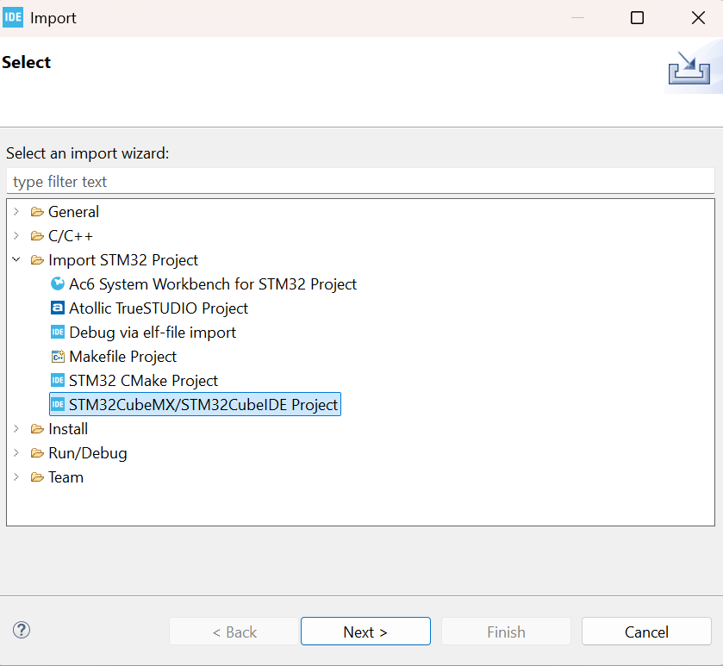
- Select Template-Ordner
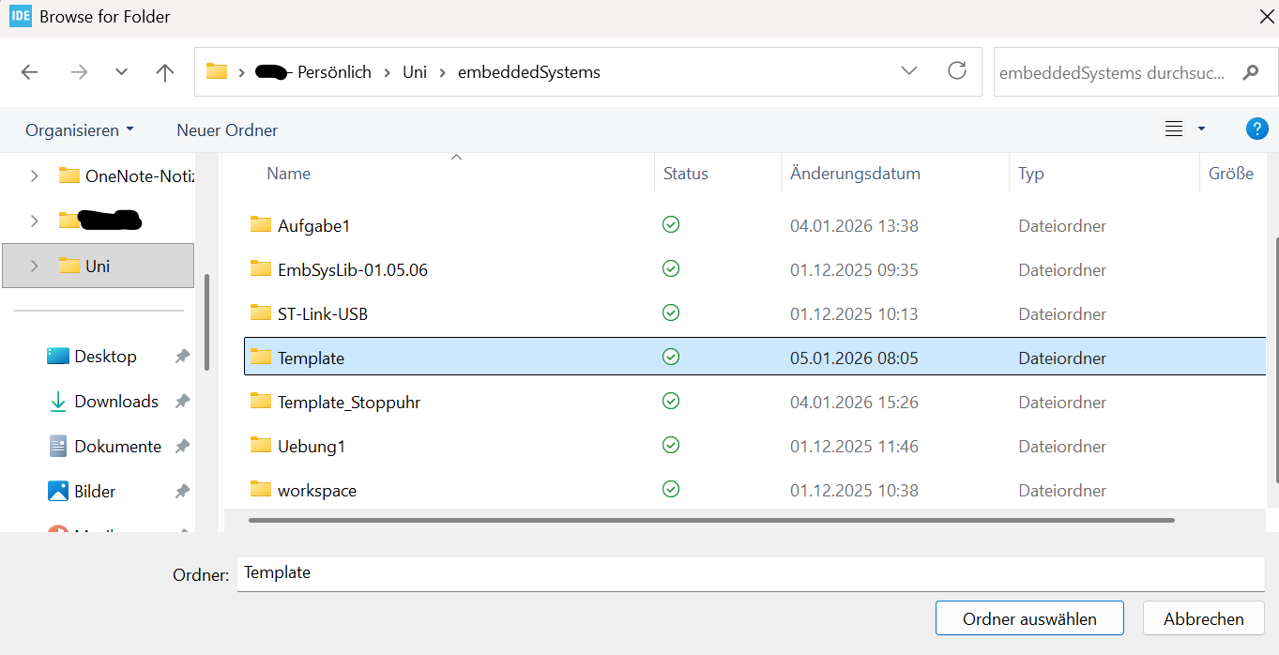
- Check Box for both Folders -> Finish
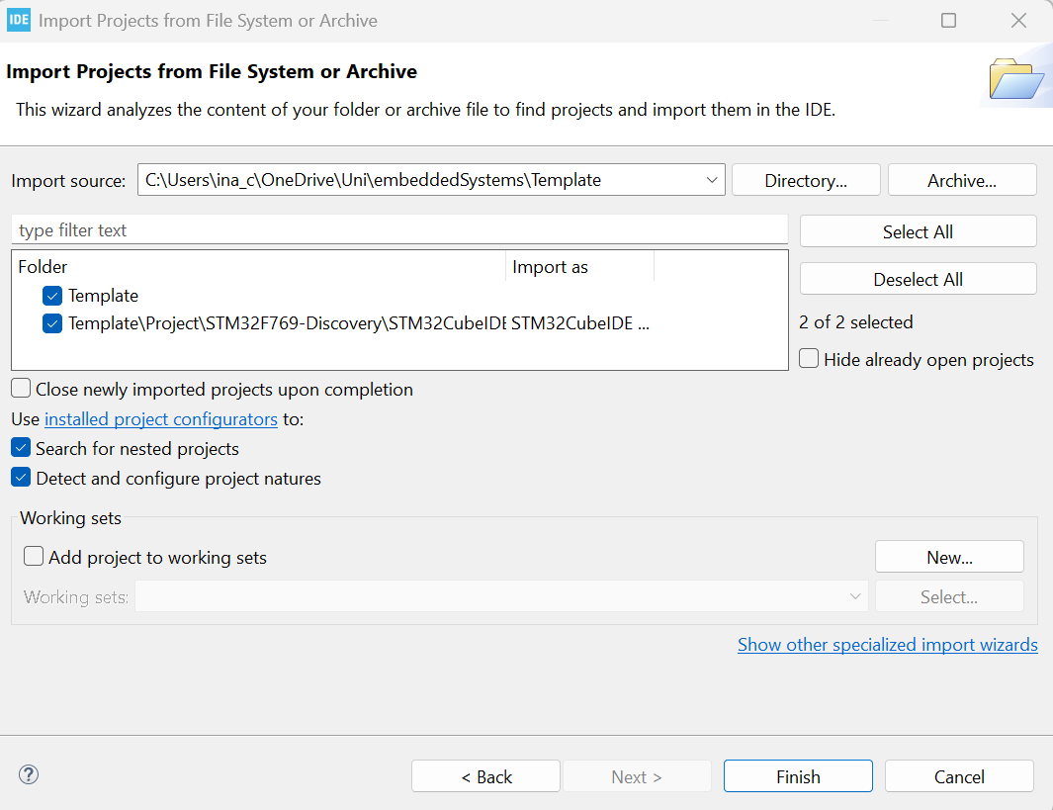
- Project -> Build All
If error occurs:
If not fatal: try to build again or try to run anyway (there might not be any affects)
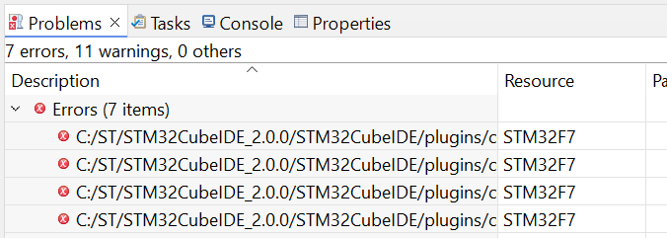
- Connect microcontroller-PCP to pc via programming cable
- Run -> Run

